1st Sunday in Lent

CHRIST LUTHERAN CHURCH | Lodi, California
March 9, 2025

WELCOME TO WORSHIP
Welcome to Christ Lutheran Church. We pray that your soul will be strengthened by the good news about God’s grace, love, and forgiveness given to us. If you would like to learn more about our church, please speak with our pastor or one of our members after the service.
- Bathrooms are located in the fellowship hall. A changing table is located in the women’s bathroom.
WORSHIP THEME
The Son of God defeats temptation for us. In his battle against the devil, we see our champion: one who has come to be tempted and tested just as we are, yet lives without sin. Praise the Lord for his powerful victory!

Matins
Matins was the service that marked the beginning of a new day for the monastic orders. Morning is a natural and necessary time for prayer, praise, and worship. As we begin not just a new day, but a new week, we glorify God and ask for his blessing.
HYMN God Moves in a Mysterious Way|CW93 420
M: In the name of the Father, and of the Son, and of the Holy Spirit.
C: Amen.
M: O Lord, open my lips
C: And my mouth shall declare your praise.
M: Hasten to save me, O God.
C: O Lord, come quickly to help me.

CONFESSION
M: Beloved in the Lord: let us draw near with a true heart and confess our sins to God our Father, asking him in the name of our Lord Jesus Christ to grant us forgiveness.
C: Holy and merciful Father, I confess that I am by nature sinful, and that I have disobeyed you in my thoughts, words, and actions. I have done what is evil and failed to do what is good. For this I deserve your punishment both now and in eternity. But I am truly sorry for my sins, and trusting in my Savior Jesus Christ, I pray: Lord, have mercy on me, a sinner.

absolution
M: God, our heavenly Father, has been merciful to us and has given his only Son to be the atoning sacrifice for our sins. Therefore, as a called servant of Christ and by his authority, I forgive you all your sins in the name of the Father and of the Son ✙ and of the Holy Spirit.
C: Amen
PRAYER OF THE DAY
M: The Lord be with you.
C: And also with you.
M: Let us pray.
Lord our strength, the battle of good and evil rages within and around us, and our ancient foe tempts us with his deceits and empty promises. Keep us steadfast in your Word, and when we fall, raise us up again and restore us through your Son, Jesus Christ our Lord, who lives and reigns with you and the Holy Spirit, one God, now and forever.
C: Amen
M: The Spirit of the Lord fills the world. Let us worship him.
O COME LET US SING TO THE LORD
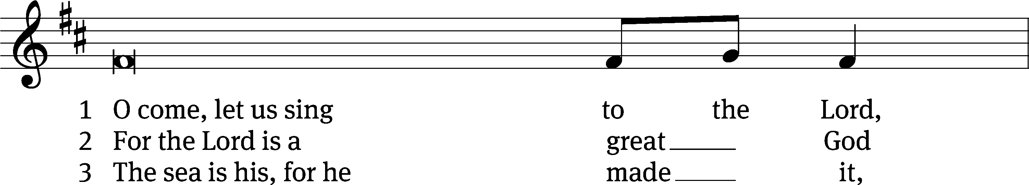
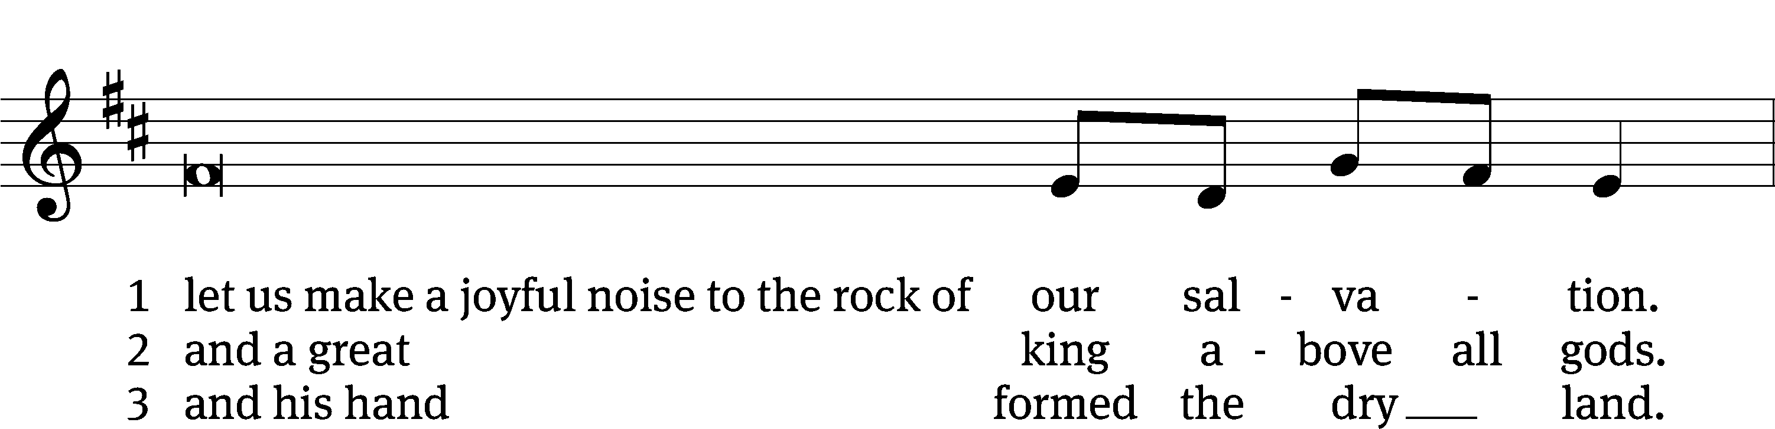
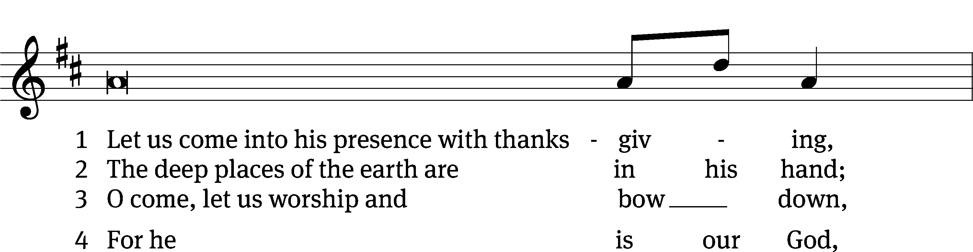
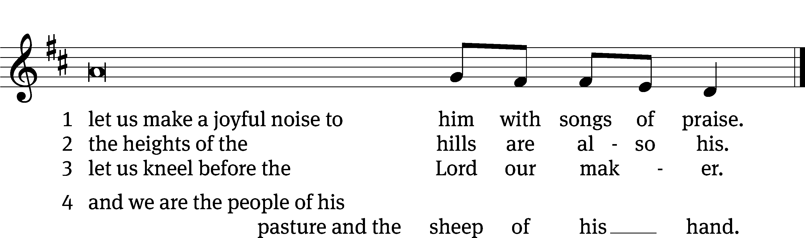
FIRST LESSON 1 Samuel 17:4-11,32-40,45-59
The Lord raised up David to be the champion for his people, and won the battle on David’s behalf.
⁴ A champion named Goliath, who was from Gath, came out of the Philistine camp. His height was six cubits and a span. ⁵ He had a bronze helmet on his head and wore a coat of scale armor of bronze weighing five thousand shekels; ⁶ on his legs he wore bronze greaves, and a bronze javelin was slung on his back. ⁷ His spear shaft was like a weaver’s rod, and its iron point weighed six hundred shekels. His shield bearer went ahead of him.

⁸ Goliath stood and shouted to the ranks of Israel, “Why do you come out and line up for battle? Am I not a Philistine, and are you not the servants of Saul? Choose a man and have him come down to me. ⁹ If he is able to fight and kill me, we will become your subjects; but if I overcome him and kill him, you will become our subjects and serve us.” ¹⁰ Then the Philistine said, “This day I defy the armies of Israel! Give me a man and let us fight each other.” ¹¹ On hearing the Philistine’s words, Saul and all the Israelites were dismayed and terrified.
³² David said to Saul, “Let no one lose heart on account of this Philistine; your servant will go and fight him.”
³³ Saul replied, “You are not able to go out against this Philistine and fight him; you are only a young man, and he has been a warrior from his youth.”
³⁴ But David said to Saul, “Your servant has been keeping his father’s sheep. When a lion or a bear came and carried off a sheep from the flock, ³⁵ I went after it, struck it and rescued the sheep from its mouth. When it turned on me, I seized it by its hair, struck it and killed it. ³⁶ Your servant has killed both the lion and the bear; this uncircumcised Philistine will be like one of them, because he has defied the armies of the living God. ³⁷ The Lord who rescued me from the paw of the lion and the paw of the bear will rescue me from the hand of this Philistine.”
Saul said to David, “Go, and the Lord be with you.”
³⁸ Then Saul dressed David in his own tunic. He put a coat of armor on him and a bronze helmet on his head. ³⁹ David fastened on his sword over the tunic and tried walking around, because he was not used to them.
“I cannot go in these,” he said to Saul, “because I am not used to them.” So he took them off. ⁴⁰ Then he took his staff in his hand, chose five smooth stones from the stream, put them in the pouch of his shepherd’s bag and, with his sling in his hand, approached the Philistine.
⁴⁵ David said to the Philistine, “You come against me with sword and spear and javelin, but I come against you in the name of the Lord Almighty, the God of the armies of Israel, whom you have defied. ⁴⁶ This day the Lord will deliver you into my hands, and I’ll strike you down and cut off your head. This very day I will give the carcasses of the Philistine army to the birds and the wild animals, and the whole world will know that there is a God in Israel. ⁴⁷ All those gathered here will know that it is not by sword or spear that the Lord saves; for the battle is the Lord’s, and he will give all of you into our hands.”
⁴⁸ As the Philistine moved closer to attack him, David ran quickly toward the battle line to meet him. ⁴⁹ Reaching into his bag and taking out a stone, he slung it and struck the Philistine on the forehead. The stone sank into his forehead, and he fell face-down on the ground.
⁵⁰ So David triumphed over the Philistine with a sling and a stone; without a sword in his hand he struck down the Philistine and killed him.

⁵¹ David ran and stood over him. He took hold of the Philistine’s sword and drew it from the sheath. After he killed him, he cut off his head with the sword.
When the Philistines saw that their hero was dead, they turned and ran. ⁵² Then the men of Israel and Judah surged forward with a shout and pursued the Philistines to the entrance of Gath^{[a]} and to the gates of Ekron. Their dead were strewn along the Shaaraim road to Gath and Ekron. ⁵³ When the Israelites returned from chasing the Philistines, they plundered their camp.
⁵⁴ David took the Philistine’s head and brought it to Jerusalem; he put the Philistine’s weapons in his own tent.
⁵⁵ As Saul watched David going out to meet the Philistine, he said to Abner, commander of the army, “Abner, whose son is that young man?”
Abner replied, “As surely as you live, Your Majesty, I don’t know.”
⁵⁶ The king said, “Find out whose son this young man is.”
⁵⁷ As soon as David returned from killing the Philistine, Abner took him and brought him before Saul, with David still holding the Philistine’s head.
⁵⁸ “Whose son are you, young man?” Saul asked him.
David said, “I am the son of your servant Jesse of Bethlehem.”
PSALM Psalm 91
SECOND LESSON Hebrews 4:14–16
We approach God confidently because Jesus took our place.
¹⁴ Therefore, since we have a great high priest who has ascended into heaven, Jesus the Son of God, let us hold firmly to the faith we profess. ¹⁵ For we do not have a high priest who is unable to empathize with our weaknesses, but we have one who has been tempted in every way, just as we are—yet he did not sin. ¹⁶ Let us then approach God’s throne of grace with confidence, so that we may receive mercy and find grace to help us in our time of need.
VERSE OF THE DAY Matthew 4:10
It is written: “Worship the Lord your God, and serve him only.”

THE GOSPEL Luke 4:1–13
Jesus conquers the devil’s temptations.
4 Jesus, full of the Holy Spirit, left the Jordan and was led by the Spirit into the wilderness, ² where for forty days he was tempted by the devil. He ate nothing during those days, and at the end of them he was hungry.
³ The devil said to him, “If you are the Son of God, tell this stone to become bread.”
⁴ Jesus answered, “It is written: ‘Man shall not live on bread alone.”
⁵ The devil led him up to a high place and showed him in an instant all the kingdoms of the world. ⁶ And he said to him, “I will give you all their authority and splendor; it has been given to me, and I can give it to anyone I want to. ⁷ If you worship me, it will all be yours.”
⁸ Jesus answered, “It is written: ‘Worship the Lord your God and serve him only.”
⁹ The devil led him to Jerusalem and had him stand on the highest point of the temple. “If you are the Son of God,” he said, “throw yourself down from here. ¹⁰ For it is written:
“‘He will command his angels concerning you
to guard you carefully;
¹¹ they will lift you up in their hands,
so that you will not strike your foot against a stone.”
¹² Jesus answered, “It is said: ‘Do not put the Lord your God to the test.”
¹³ When the devil had finished all this tempting, he left him until an opportune time.

M The Gospel of the Lord.
C: Praise be to you, O Christ!

HYMN OF THE DAY A Mighty Fortress Is Our God| CW 864
SERMON Luke 4

WE PRAISE YOU, O GOD
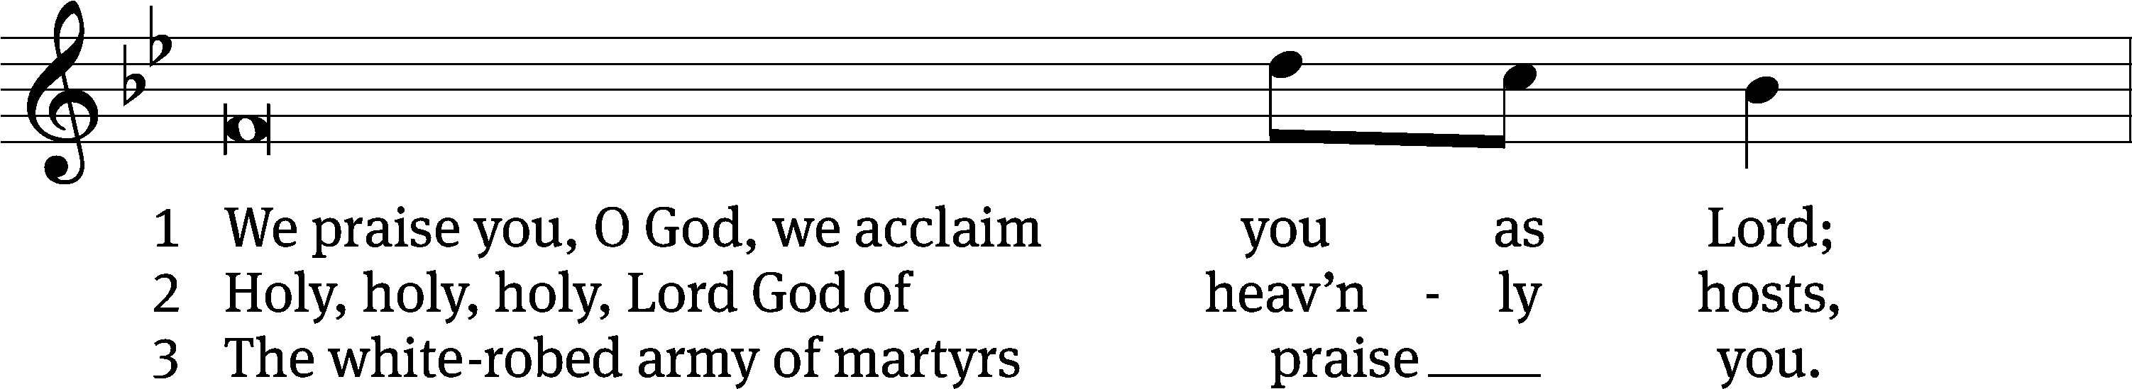
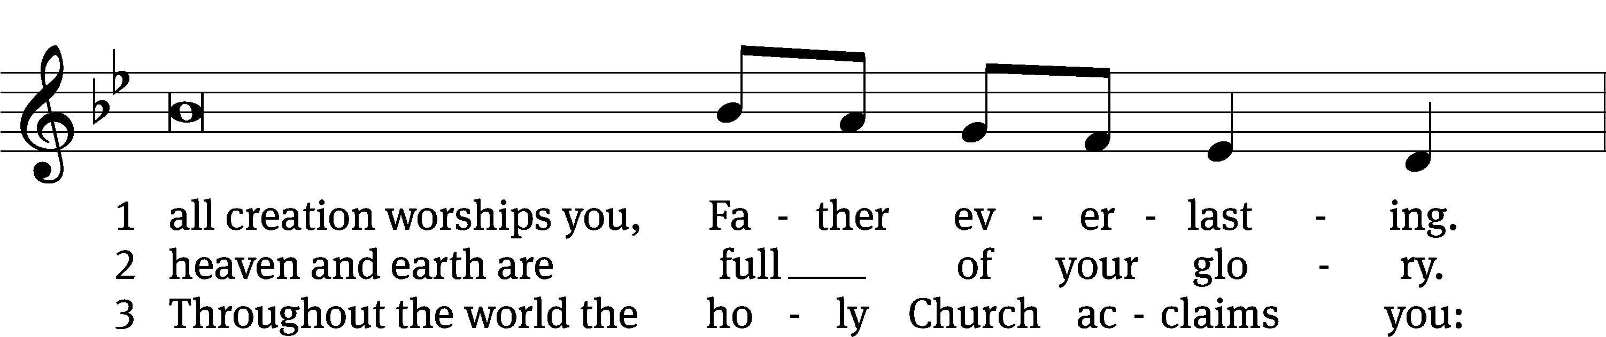
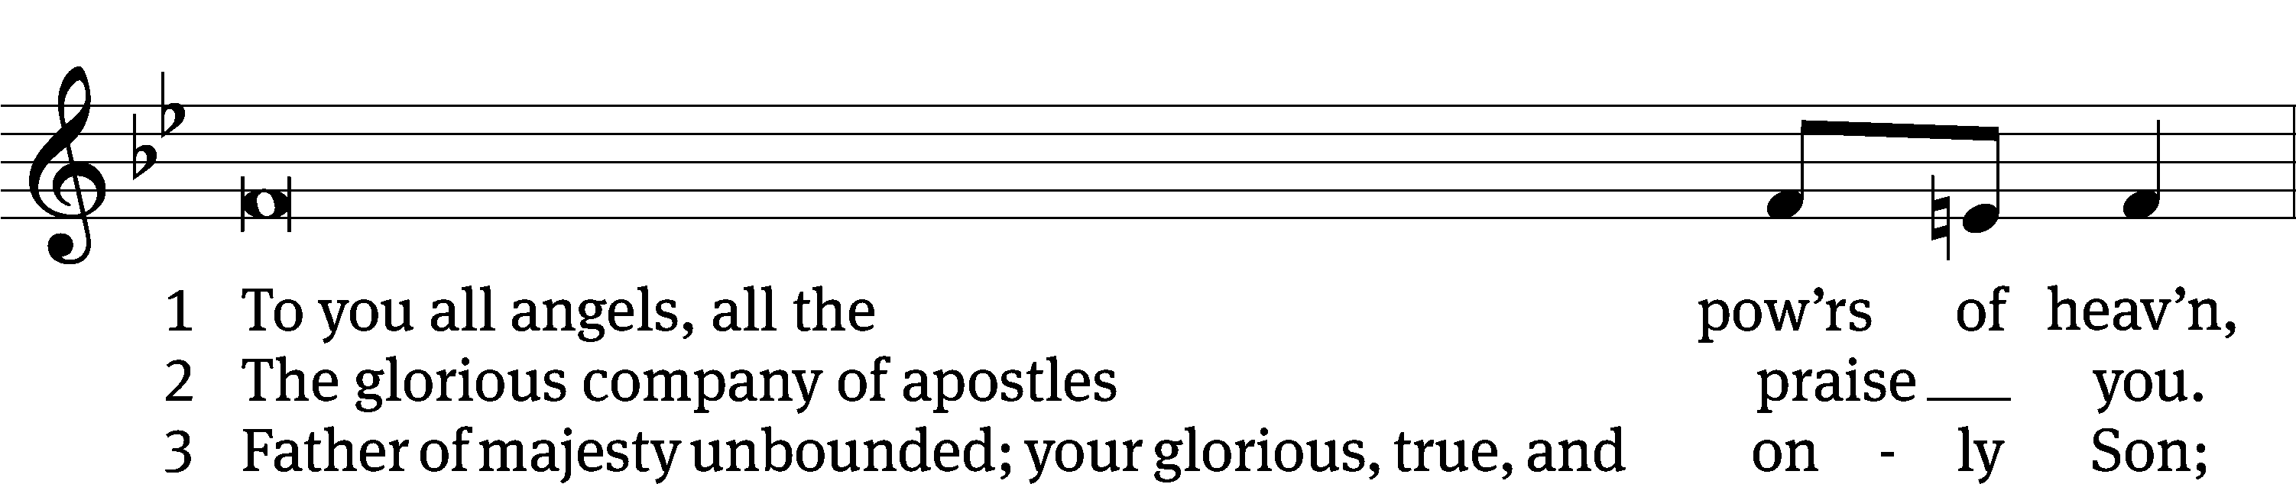
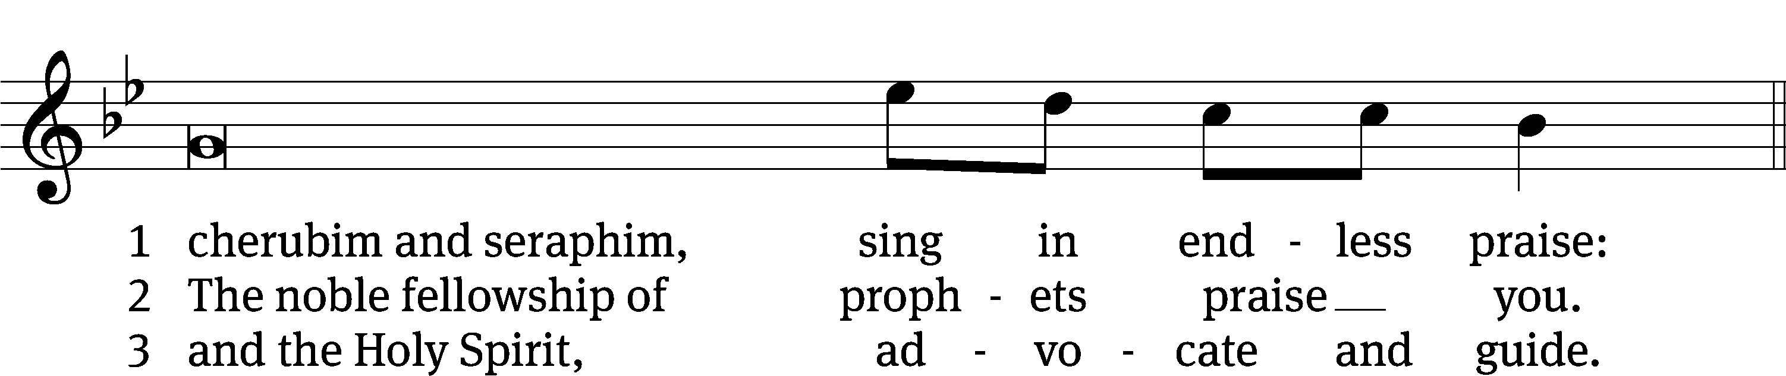
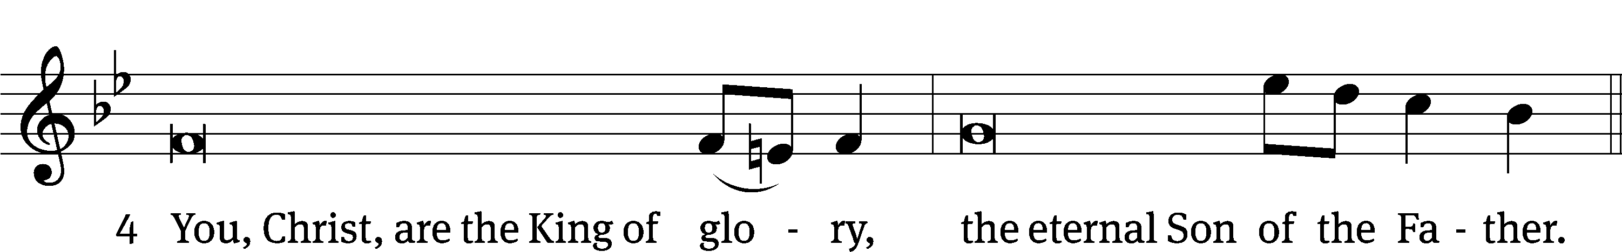

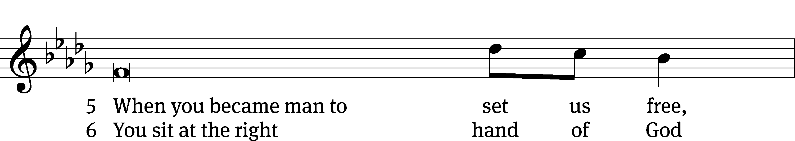
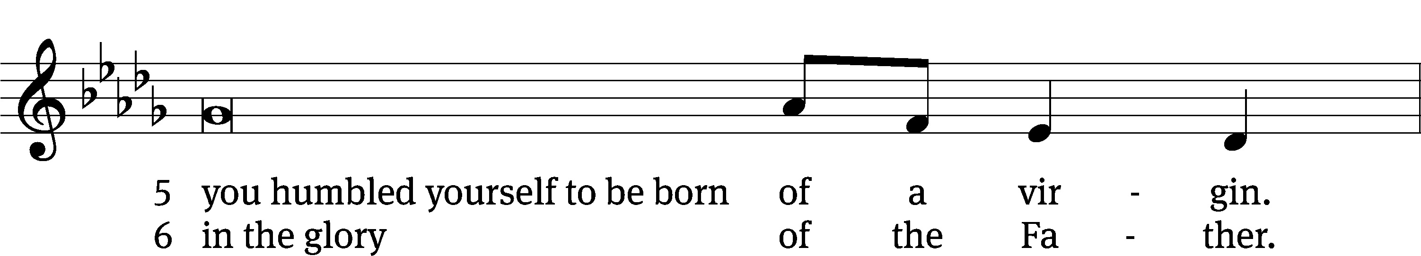
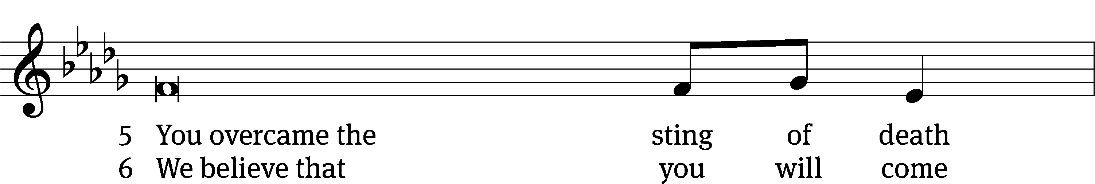
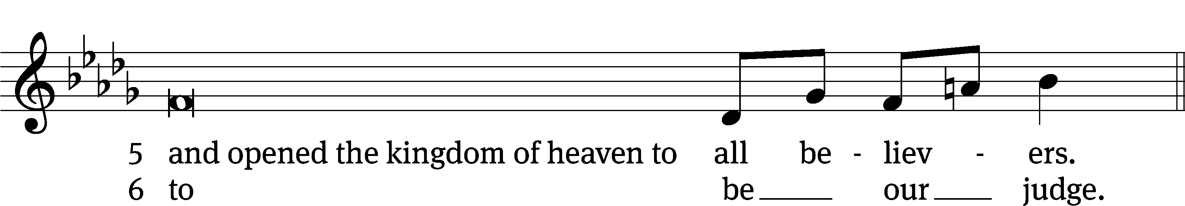

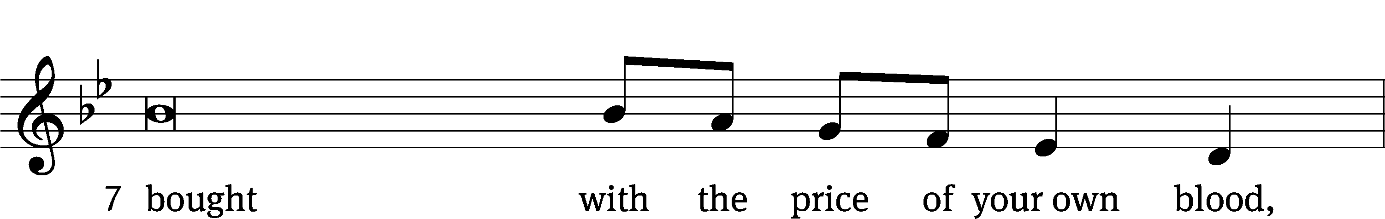
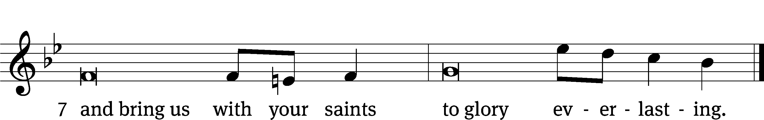

OFFERING
In response to God’s love and forgiveness, we give back a portion of what he has given us. The members of Christ Lutheran Church have joined to proclaim the gospel to this community. These offerings support that work. While our guests are welcome to participate, they should not feel obligated to do so.
PRAYER OF THE CHURCH
M: Lord Most High, You are the dwelling place of Your people. Be our refuge for the sake of Christ, who suffered temptation and death for our redemption. Preserve us from every evil and plague, and strengthen us in faith, that we may be satisfied with Your salvation. Lord, in Your mercy,
C: Hear our prayer.
M: God of all nations, You make no distinction between Jew and Greek, for everyone who calls on the name of the Lord will be saved. Protect and provide for the missionaries of Your Church as they proclaim the Word of faith and bring it near to all who will hear, so that more would confess with their mouths that Jesus is Lord and believe in their hearts that You raised Him from the dead. Lord, in Your mercy,
C: Hear our prayer.
M: Lord of all, You bestow Your riches on all who call upon You. Bless parents with all wisdom as they teach their children Your ways, that all in the household may confess with their mouths that Jesus is Lord. Lord, in Your mercy,
C: Hear our prayer.
M: Almighty God, govern the kingdoms of this world according to Your holy and gracious will. Protect authorities from every temptation of the devil, who falsely claims sovereignty over them. Equip them to curb what is evil and promote what is good. Lord, in Your mercy,
C: Hear our prayer.
M: God of all mercy, You answer those who call upon You. Hear our prayers for all people in need of healing and restoration [especially _____________]. Be with them in their trouble, and rescue them according to Your gracious will. Lord, in Your mercy,
C: Hear our prayer.
M: O Lord, everyone who believes that Jesus is Lord will not be put to shame. Unite Your people in a right confession of Your Word, and free them from disagreement over Your truth. Bring us with penitent hearts to receive the great riches of Your Son’. Lord, in Your mercy,
C: Hear our prayer.
M: Lord God, as You brought Your people to the Promised Land and gave them an inheritance of abundance, so You give us all that we have. Preserve us from greed, and grant us thankful hearts to declare Your goodness and gladly support what You will. Lord, in Your mercy,
C: Hear our prayer.
M: Lord God, heavenly Father, see how the adversary continually afflicts us and walks about as a roaring lion seeking to devour us. We implore You for the sake of the suffering and death of Your Son, Jesus Christ, to help us by the grace of the Holy Spirit and strengthen our hearts by Your Word, that our enemy would not prevail over us, but instead that we may abide evermore in Your grace and be preserved to life everlasting; through the same Jesus Christ, Your Son, our Lord, who lives and reigns with You and the Holy Spirit, one God, now and forever.
C: Amen.

LORD’S PRAYER Matthew 6:9-13; Luke 11:2-4
C: Our Father in heaven, hallowed be your name,
your kingdom come, your will be done
on earth as in heaven.
Give us today our daily bread; and forgive us our sins,
as we forgive those who sin against us;
and lead us not into temptation, but deliver us from evil.
For the kingdom, the power, and the glory are yours
now and forever. Amen.
THE BLESSING
M: The Lord bless you and keep you.
The Lord make his face shine on you and be gracious to you.
The Lord look on you with favor and ✙ give you peace.
C: Amen.
CLOSING HYMN If God Himself Be For Me| CW 819

COPYRIGHT INFORMATION
Content requiring a copyright license is reproduced under OneLicense.net #A-718312. All rights reserved. The Common Service: Texts revised from The Lutheran Hymnal, 1941. Music revised by James Engel. Scripture Quotations: From the Holy Bible, New International Version (NIV 1984), © 1973, 1978, 1984 by Biblica, Inc.


13009 N. Elderberry Ct.
Lodi, CA 95242
www.christlodi.org
209-368-6250
Pastor Timothy Leistekow
WELCOME TO CHRIST EV. LUTHERAN CHURCH!
We preach a message of forgiveness, hope and peace
through the death and resurrection of Jesus Christ.
Families and individuals of all ages will find opportunities
both to grow and to serve.
Our mission statement:
Look what Christ is doing!
He binds us together in fellowship
He gathers us in for worship
He builds us up for service
He sends us out with the gospel

“Now you are the body of Christ,
and each one of you is a part of it.”
(1 Corinthians 12:27)

